GCP Architect Certification
Why cloud
To manage variable load – holidays and weekends
Startups – procure infrastructure with peak load – with cloud , on demand resource provisioning

Google cloud regions and zones

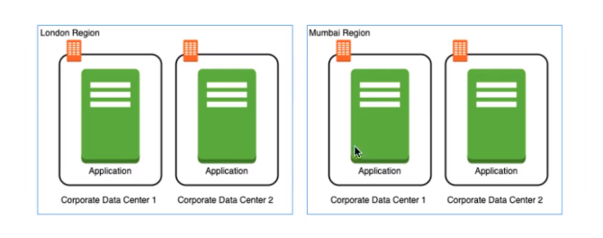
Advantages
High availability
Low latency
Global footprint
Adherence to government regulations

Zones – High availability in the same region

Google compute engine

Google compute engine – provision & manage virtual machines

Features
- Create and manage lifecycle of VM instances
- Load balancing and auto scaling for multiple VM instances
- Attach storage (& network storage) to your VM instances
- Manage network connectivity and configuration for your VM instances

Create a VM
- Name
- Labels
- Region & Zones
- Machine configuration – General purpose, Compute optimized , Memory optimized
- Public images
- Firewall configuration

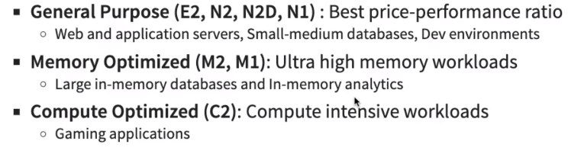

SSH into the VM’s and run the commands

- sudo su
- apt update
- apt install apache2
- ls /var/www/html
- echo "Hello World!"
- echo "Hello World!" > /var/www/html/index.html
- echo $(hostname)
- echo $(hostname -i)
- echo "Hello World from $(hostname)"
- echo "Hello World from $(hostname) $(hostname -i)"
- echo "Hello world from $(hostname) $(hostname -i)" > /var/www/html/index.html
- sudo service apache2 start

Internal IP address
External IP address

Virtual machine stopped , external ip address is removed , internal ip address will be same . When restarted it will give an new external ip address .

Quick and dirty way to have constant ip address to VM is by assigning static address . Other option would be a load balancer.Static ip address should be in the same region .

- #!/bin/bash
- apt update
- apt -y install apache2
- echo "Hello world from $(hostname) $(hostname -I)" > /var/www/html/index.html

Simplify web sever with compute engine startup
Instance Template

Reduce launch time with custom image . Custom image is created from the disk attached with the the VM.

Sole tenant nodes – dedicated hardware

Want to allow http traffic to your VM – configure firewall rules

Google Kubernetes Engine

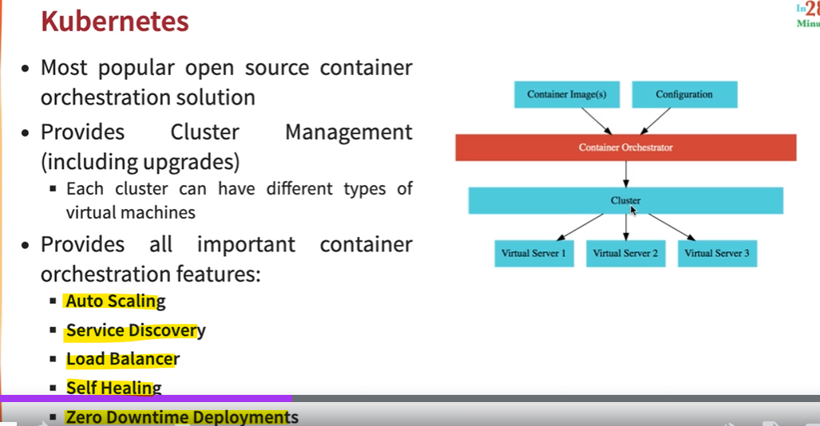

Google Kubernetes Engine (GKE)

- Managed Kubernetes service
- Minimize operations with auto-repair (repair failed nodes) and auto-upgrade (use latest version of K8S always) features
- Provides Pod and cluster autoscaling
- Enable cloud logging and cloud monitoring with simple configuration
- Uses container optimized OS , a hardened OS built by Google
- Provides support for persistent disks and local SSD

Create a GKE Cluster

- Create a kubernetes cluster with the default node pool
  - glcoud container clusters create or use cloud console
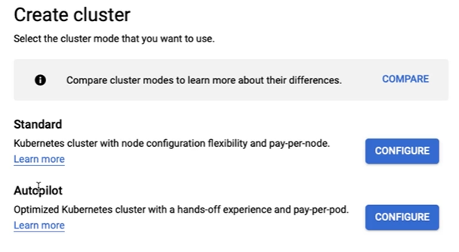
Autopilot – google takes care , Standard – we need to take care for complete management

Autopilot
- New mode of operation for GKE
- Reduce your operational costs in running Kubernetes clusters
- Provides an hands-off experience
  - Do not worry about managing the cluster infrastructure (nodes, node pools)
  - GKE will manage the cluster for you

For now lets select standard

- gcloud config set project my-kubernetes-project-304910
- gcloud container clusters get-credentials my-cluster --zone us-central1-c --project my-kubernetes-project-304910
- kubectl create deployment hello-world-rest-api --image=in28min/hello-world-rest-api:0.0.1.RELEASE
- kubectl get deployment
- kubectl expose deployment hello-world-rest-api --type=LoadBalancer --port=8080
- kubectl get services
- kubectl get services --watch
- curl 35.184.204.214:8080/hello-world
- kubectl scale deployment hello-world-rest-api --replicas=3
- gcloud container clusters resize my-cluster --node-pool default-pool --num-nodes=2 --zone=us-central1-c
- kubectl autoscale deployment hello-world-rest-api --max=4 --cpu-percent=70
- kubectl get hpa
- kubectl create configmap hello-world-config --from-literal=RDS_DB_NAME=todos
- kubectl get configmap
- kubectl describe configmap hello-world-config
- kubectl create secret generic hello-world-secrets-1 --from-literal=RDS_PASSWORD=dummytodos
- kubectl get secret
- kubectl describe secret hello-world-secrets-1
- kubectl apply -f deployment.yaml
- gcloud container node-pools list --zone=us-central1-c --cluster=my-cluster
- kubectl get pods -o wide

- kubectl set image deployment hello-world-rest-api hello-world-rest-api=in28min/hello-world-rest-api:0.0.2.RELEASE
- kubectl get services
- kubectl get replicasets
- kubectl get pods
- kubectl delete pod hello-world-rest-api-58dc9d7fcc-8pv7r

- kubectl scale deployment hello-world-rest-api --replicas=1
- kubectl get replicasets
- gcloud projects list

- kubectl delete service hello-world-rest-api
- kubectl delete deployment hello-world-rest-api
- gcloud container clusters delete my-cluster --zone us-central1-c

2) Login to cloud shell
- gcloud config set project my-kubernetes-project-304910
3) Connect to the Kubernetes cluster
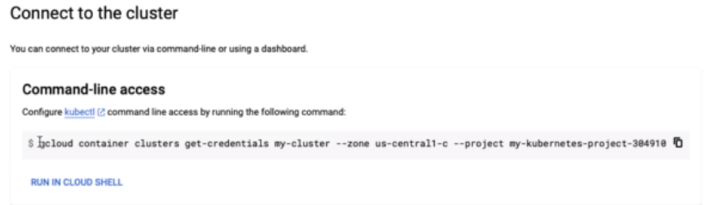

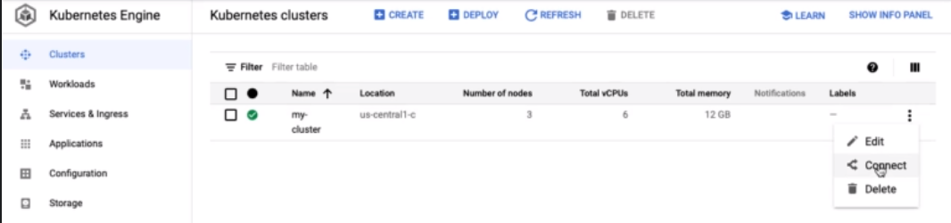

4 Deploy microservice to kubernets
Create deployment & service using kubectl commands
Kubectl create deployment hello-world-rest-api –image=in28min/hello-world-rest-api:0.0.1.RELEASE

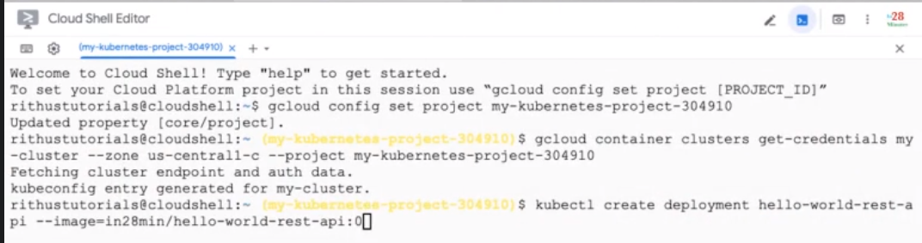
Kubectl get deployment

kubectl expose deployment hello-world-rest-api --type=LoadBalance --port=8080

Exploring GKE in GCP Console

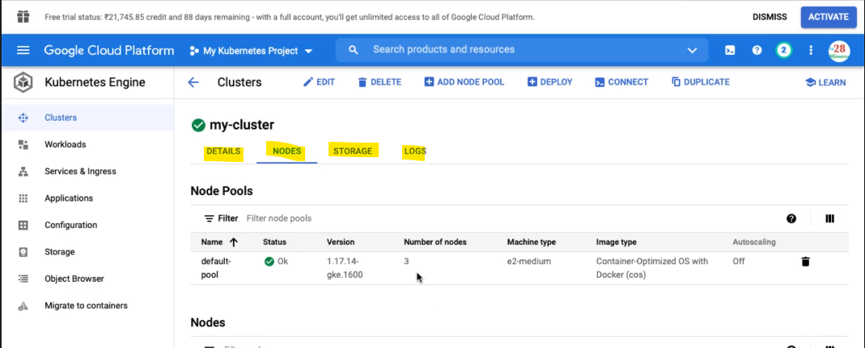

If you have specific requirement to run nodes of specific nodes , we can create a add a node pool

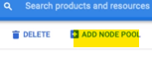

Workload we can see the deployments

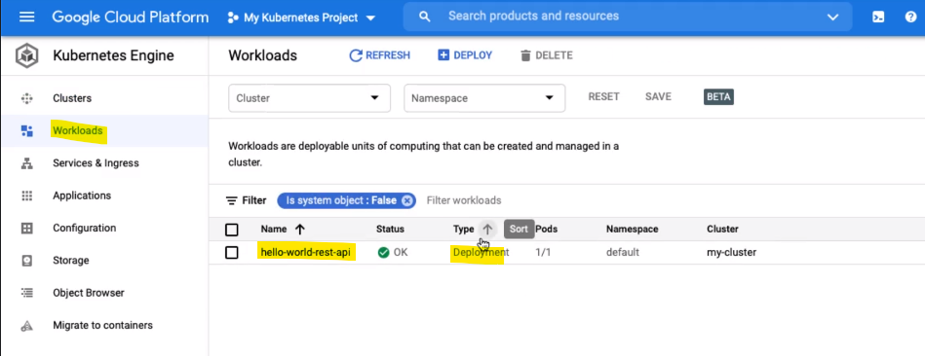

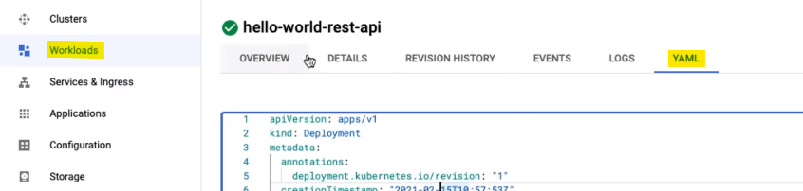

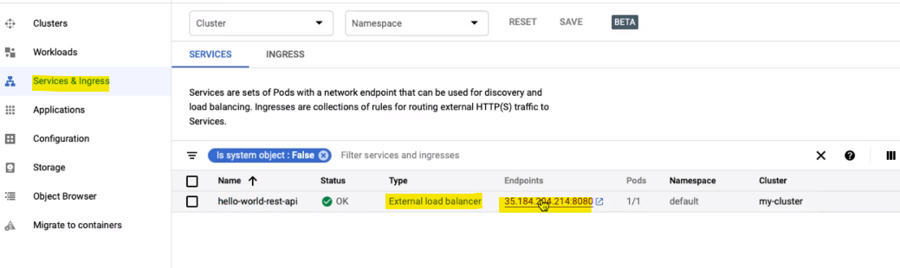
Services are sets of Pods with a network endpoint that can be used for discovery and load balancing . Ingresses are collection of rules for routing external HTTP(S) traffic to services

6) Kubernets Journey Scaling Deployments and Resizing Node Pools

kubectl scale deployment hello-world-rest-api –replicas=2

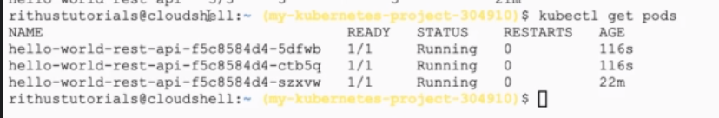

Increase number of nodes in your kubernets cluster

gcloud container clusters resize my-cluster –node-pool my-node-pool –num-nodes 5

Autoscaling of pods , Config Map and Secrets

kubectl autoscale deployment heelo-world-rest-api --max=4 –cpu-percent=70

Setup autoscaling for your kubernetes cluster

gcloud container clusters update cluster-name --enable-autoscaling --min-nodes =1 --max-nodes=10

Config Map – kubectl create configmap todo-web-application-config --from-literal=RDS_DB_NAME=todos

kubectel get configmap

kubernetes secrets - kubectl create secret generic todo-web-application-secrets-1 –from-literal=RDS_PASSWORD=dumytodos

Exploring Kubernets Deployment with YAML declarative configuration

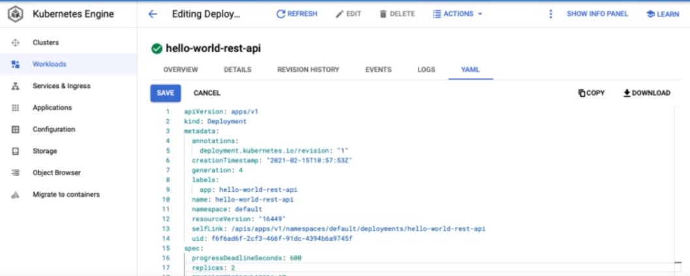

YAML – declarative style , other is imperative style

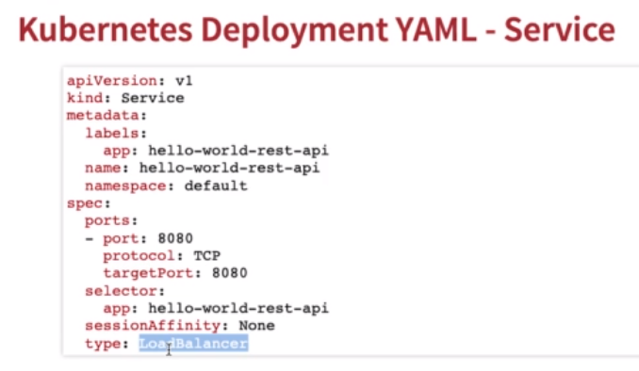

Gcloud container node-pools create pool_name --cluster cluster_name
gcloud container node-poos list --cluster cluster-name

Deploy the new microservice to the new pool by setting up nodeSelector in the deployment.yaml

nodeSelector:cloud.google.com/gke-nodepool:POOL_NAME

Delete microservice

Kubectl delete service
Kubectl delete deployment

gcloud container clusters delete

Google Kuberenets Engine Cluster

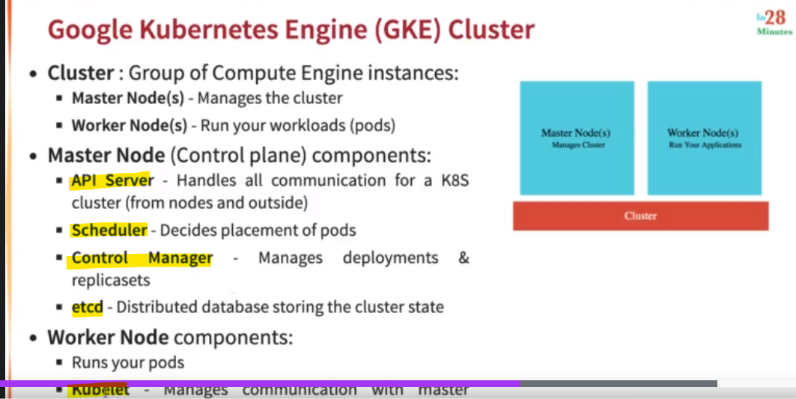

GKE Clusters

Zonal Cluster : single zone , multi zone
Regional cluster : zones of given region
Private cluster : VPC-native cluster , nodes only have internal IP addresses
Alpha cluster : Cluster with alpha APIs – early feature API’s . Used to test new K8S features

Kubernets – Pods

- Smallest deployable unit in kubernetes
- A pod contains one or more containers
- Each pod is assigned an ephemeral IP address
- All containers in pod share : Network , storage , IP address , Ports and Volumes
- POD statuses : running/pending/succeded/failed/unknown

Deployments Vs Replica Sets

Set new image in a deployment hello-world-rest-api hello-world-rest-api=in28min/hello-world-rest-api:0.0.2.RELEASE
Deployment manages new releases ensuring zero downtime

Replica set ensures that a specific number of pods are running for a specific microservice version

New replica set is created when a new image is set

Kubectl scale deployment m2 --replicas=2

Understanding services in Kubernetes

- Cluster IP – you want your micro service only to be available inside the cluster
- LoadBalance – exposes service externally using a cloud providers load balancer
- NodePort – exposes service on each Node’s IP at a static port (the NodePort)
You do not wan to create an external load balancer for each micro service – you can create one ingress component to load balance multiple micro services

Using kubernetes ingress to provide external access to services
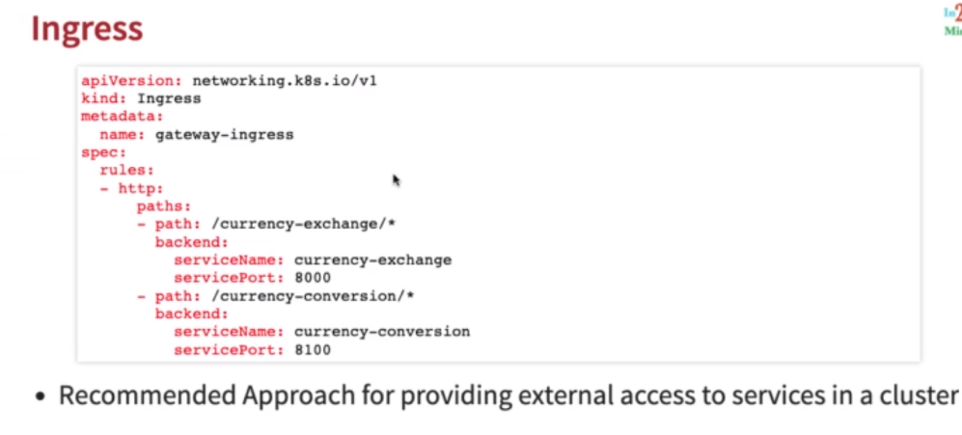

Ingress provides
- Load balancing and SSL termination
- Control traffic by defining rules on the ingress resource
- Recommendation : NodePort service for each microservice . Expose using a Ingress
- Advantage – one load balancer can serve multiple microservices

Google Container Registry – Image Repository

Fully managed container registry provided by GCP
gcr.io/projectname/helloworld:1

Best practices by creating docker images

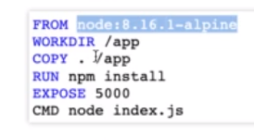
FROM – sets a base image
WORKDIR – sets the working directory
RUN – execute a command
EXPOSE – informs docker about the port that the container listens on at runtime
COPY – copies new files or directories into image
CMD – default command for an executing container

Considerations

- Use light weight images – preferably alpine linux to ubuntu
- Do not copy anything that’s unnecessary (node_modules for example)
- Move things that change less often to the top to enable LAYER REUSE
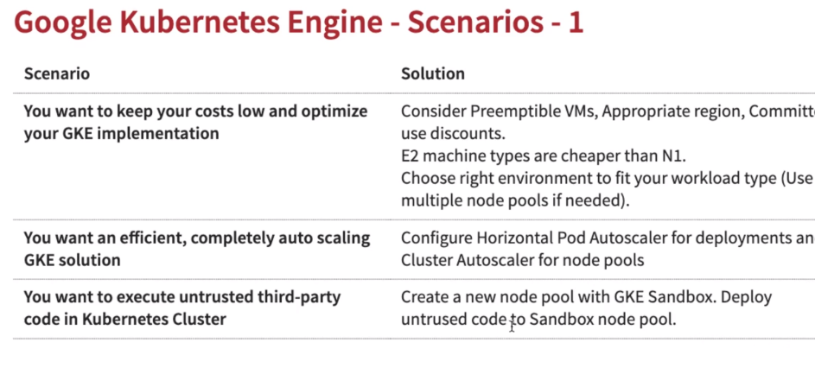
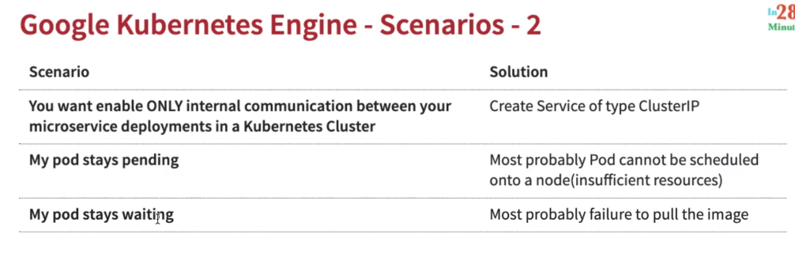

Delete the deployment
- Delete service
- Delete deployment
- Delete cluster – gcloud container cluster delete my-cluster
- Delete project

Asynchronous Communication in Google Cloud with Pub/Sub
Advantages
- Decoupling
- Availability
- Scalability
- Durability
Pub/Sub
- Reliable , scalable , fully-managed asynchronous messaging service
- Auto scale to process billions of messages per day
- Event ingestion and delivery for streaming analytics pipelines
- Supports push and pull messages deliveries.

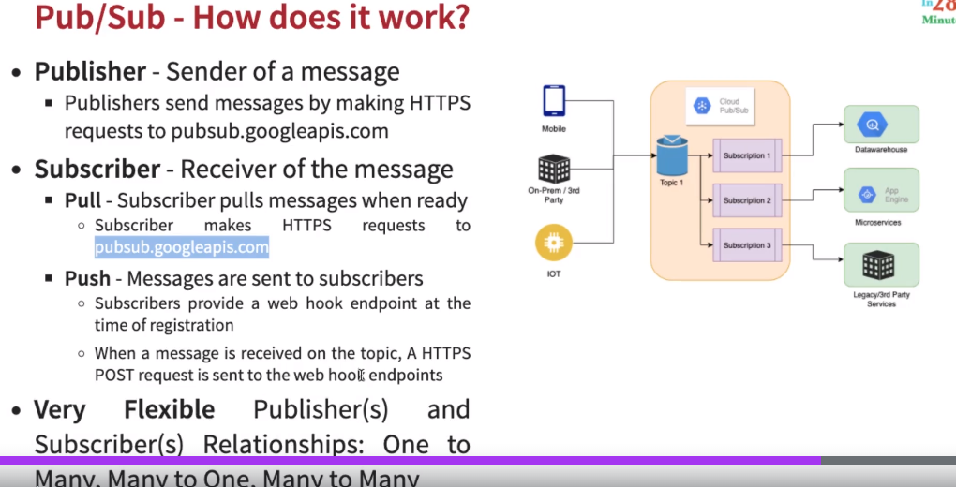

- gcloud config set project glowing-furnace-304608
- gcloud pubsub topics create topic-from-gcloud
- gcloud pubsub subscriptions create subscription-gcloud-1 --topic=topic-from-gcloud
- gcloud pubsub subscriptions create subscription-gcloud-2 --topic=topic-from-gcloud
- gcloud pubsub subscriptions pull subscription-gcloud-2
- gcloud pubsub subscriptions pull subscription-gcloud-1
- gcloud pubsub topics publish topic-from-gcloud --message="My First Message"
- gcloud pubsub topics publish topic-from-gcloud --message="My Second Message"
- gcloud pubsub topics publish topic-from-gcloud --message="My Third Message"
- gcloud pubsub subscriptions pull subscription-gcloud-1 --auto-ack
- gcloud pubsub subscriptions pull subscription-gcloud-2 --auto-ack
- gcloud pubsub topics list
- gcloud pubsub topics delete topic-from-gcloud
- gcloud pubsub topics list-subscriptions my-first-topic
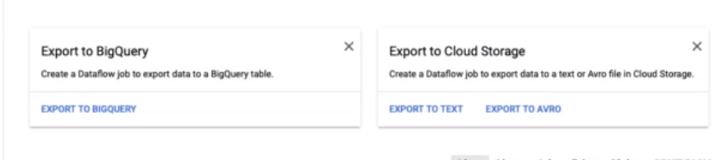
- Create a dataflow job to export data to a BigQuery table
- Create a dataflow job to export data to a text or Avro file in cloud storage
Settings
- Retain unacknowledged messages for a specific duration .
- Pub/Sub can automatically delete a subscription after a specified period if there is no subscriber activity such as open connections
- Acknowledgement deadline – how long pub/sub waits for the subscriber to acknowledge receipt before resending the message
- Subscription filter – only receive messages that match the filter
- Message ordering – order messages with an ordering key
- Dead lettering – enable dead lettering , subscriptions may configure a maximum number of delivery attempts.

Pub/Sub Lite API - a zonal messaging service optimized for costs

UseCases

- Convert synchronous to asynchronous workflows
- Apply transformations to IOT data stream
- Some use cases need in-order , exactly-once processing
- Add dataflow into flow to enable message deduplication (exactly once processing)
- Pub Sub supports in order processing

Cloud Dataflow

It provides unified streaming and batch data processing that’s serverles , fast and cost-effective

Create job from template – job from existing dataflow templates
Export from different sources
- Hive to BigQuery
- Kafka to BigQuery
- Pub/Sub Avro to BigQuery
- Pub/Sub Subscription to BigQuery
- Cloud BigTable to SequenceFile Files on Cloud Storage
- Cloud BigTable to Avro Files on Cloud Storage

Datastore to TextFiles on Cloud Storage
Text files on cloud storage to Datastore

Pub/Sub Avro to BigQuery
Pub/Sub Subscription to BigQuery

  - Pub/Sub -> Dataflow -> BigQuery
  - Pub/Sub -> Dataflow -> Cloud Storage
  - Cloud Storage -> Dataflow -> Bigtable/CloudSpanner/DataStore/BigQuery
  - Bulk compress files in Cloud Storage (Batch)
  - Convert file formats between Avro,Parquet & csv

Google Cloud App Engine

Earliest managed google cloud managed services .

- Simplest way to deploy and scale your applications in GCP
- Supports Java , .Net , Node.js PHP , Python , Ruby
- No usage charges – pay for resources provisioned
- Automatic load balancing & auto scaling
- Managed platform updates & application health monitoring
- Application versioning & traffic splitting

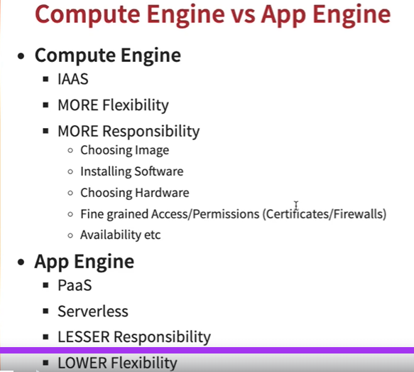

App Engine Environments

  - Standard : Applications run in language specific sandboxes
    - V1 : Java , Python , PHP , Go
    - V2 : Java , Python , PHP , Node.js , Ruby , Go
    - Pricing instance hours
    - Scaling – manual , basic , automatic
    - Scaling to zero – yes
    - Rapid scaling – yes
    - Request timeout – 10 mins
    - Local disk – can write to /tmp
    - SSH for debugging No
  - Flexible : Application instances run within docker containers
    - Makes use of compute engine virtual machines
    - Support any runtime
    - Provides access to background processes and local disks
    - vCPU , Memory & Persistent Disks
    - Manual , Automatic
    - No Minimum one instance
    - Rapid scaling – no
    - Request time out – 60 mns
    - New disk on start up
    - SSH for debugging yes

App Engine Hierarchy

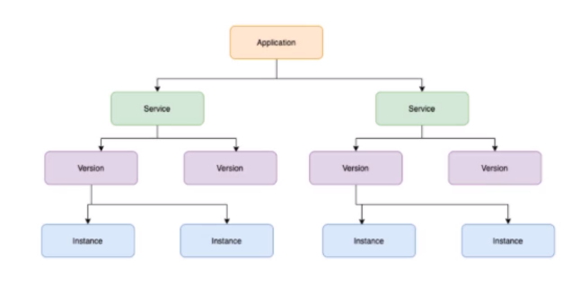

App Engine – Scaling Instances

- Automatically scale instances based on load
- Auto scale – based on Target CPU utilization , throughput utilization , max concurrent requests
- Configure max and min instances

Basic – instances are created as and when requests are received:
- Instances are shutdown if zero requests
- NOT supported by App Engine Flexible Environment
- Configure Max instances and idle timeout

Manual – adjust number of instances manually over time

- cd default-service
- gcloud app deploy
- gcloud app services list
- gcloud app versions list
- gcloud app instances list
- gcloud app deploy --version=v2
- gcloud app versions list
- gcloud app browse
- gcloud app browse --version 20210215t072907
- gcloud app deploy --version=v3 --no-promote
- gcloud app browse --version v3
- gcloud app services set-traffic split=v3=.5,v2=.5
- gcloud app services set-traffic splits=v3=.5,v2=.5
- watch curl https://melodic-furnace-304906.uc.r.appspot.com/
- gcloud app services set-traffic --splits=v3=.5,v2=.5 --split-by=random

- cd ../my-first-service/
- gcloud app deploy
- gcloud app browse --service=my-first-service

- gcloud app services list
- gcloud app regions list

gcloud app browse –version=v3 –no-promote (deployed without any traffic)

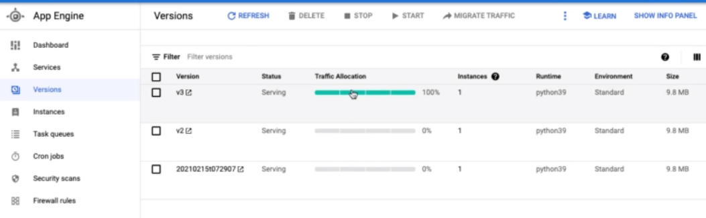

Drag and drop the app.yml file and content into the cloud shell editor

--------------------------------------------------------------------------------------------------------------------------------------------------------

